2019 sem 2: WTF is eggsham??
Practice eggsham questions:

If you want to contribute just request for edit access.
These are by no means definitive, if you had a different answer please write it in as well
Part A MCQ
Q1. A
Q2. D
Q3. B
Q4. B tested on https://scastie.scala-lang.org/ value is 35
Q5. B
Q6. B
Q7. A
Q8. E
Q9. B
Q10. B
Q11. D - I swear this should be B, swear on ur mum’s life? Pretty sure it doesn’t do resource management and isn’t really data warehouse system
Actually idk, if by data warehouse system it just refers to the processing of data within a data warehouse yeah i see that argument too. Very semantic based question :/

Actually nah i think it is B, because it doesn’t provide resource management at all. But yeah poorly worded question
Q12. A
Q13. D
Q14. D
Q15. A
Q16. D
Q17. C? [I think so] (yeah not sure about this one). I think it can be D. Data Access Patterns is treated as Privacy Preservation and not Confidentiality Protection. I Agree
Q18. E
Part B Short Answer
Q1. A)
Cloud Computing is a model for enabling ubiquitous, convenient, on-demand network access to a shared pool of configurable computing resources (e.g., networks, servers, storage, applications, and services) that can be rapidly provisioned and released with minimal management effort or service provider interaction.
B)
On-demand self-service: A consumer can unilaterally provision computing capabilities, such as server time and network storage, as needed automatically without requiring human interaction with each service provider.
Broad network access: Capabilities are available over the network and accessed through standard mechanisms that promote use by heterogeneous thin or thick client platforms (e.g., mobile phones, tablets, laptops, and workstations).
Resource pooling: The provider’s computing resources are pooled to serve multiple consumers using a multi-tenant model, with different physical and virtual resources dynamically assigned and reassigned according to consumer demand.
Rapid elasticity: Capabilities can be elastically provisioned and released, in some cases automatically, to scale rapidly outward and inward commensurate with demand.
Measured service: Cloud systems automatically control and optimize resource use by leveraging a metering capability at some level of abstraction appropriate to the type of service (e.g., storage, processing, bandwidth, and active user accounts).

Q2. A)
A VM is a software-based environment geared to simulate a hardware-based environment. Container technology offers the opportunity to virtualize the operating system itself So Docker container looks like a VM, but docker container is much lighter than a VM.

(I think this could be improved a fair bit by putting pros and cons but I cbf atm)

B)
By utilising docker, software developers can write their code to be run on a container which enables them to drastically reduce the time for deployment as everyone who can run the container will get the same behaviour regardless of what system they are on.
(THIS COULD BE WORDED BETTER BUT I CBF)
Q3 A)
i) DFS is a file system with data stored on a server. The data is accessed and processed as if stored on the local client machine. Servers have full control over data and give access to clients. Multiple users share and distribute files and storage resources. DFS manages a set of dispersed storage devices. Implements the classic time sharing model of a file system.
ii)
A NFS is one of the two common DFS architectures. An NFS enables the storage and retrieval of data from multiple disks and directories across a shared network. NFS enables local users to access remote data and files in the same way they are accessed locally.

iii)
- A DFS architecture.
- Consists of clusters of servers sharing responsibility.
- Provide features like location independent addressing and redundancy, improving reliability and reducing complexity of other parts of cluster.
- Parallel file systems are a type of CFS that spread data across many storage nodes, for redundancy/performance.

B)
https://cs.stanford.edu/~matei/courses/2015/6.S897/slides/gfs.pdf

Write Operation:
1. Client asks master which chunkserver holds lease for chunk and for the location of replicas
2. Master replies with ID of primary replica and locations of secondary replicas. Client caches this data.
3. Client pushes data to all replicas
4. Once all replicas acknowledge receiving data, client sends write request to primary
5. Primary forwards write request to all secondaries
6. Secondaries reply with acknowledgement of completed write.
7. Primary replies to client, indicating completion.

Q4. A)
Consistency
All data replicas stored on different machines contain the same version of data.
Client always has the same view of the data (no matter which cluster node).
Availability
System remains operational on failing nodes.
All clients can always read and write on data and writes are propagated to all replicas simultaneously.
Partition tolerance
System can have multiple entry points for data read, write, replication, and propagation. System remains operational on system split (communication malfunction).
System works well across physical network partitions.
CAP Theorem: Satisfying all three at the same time is impossible

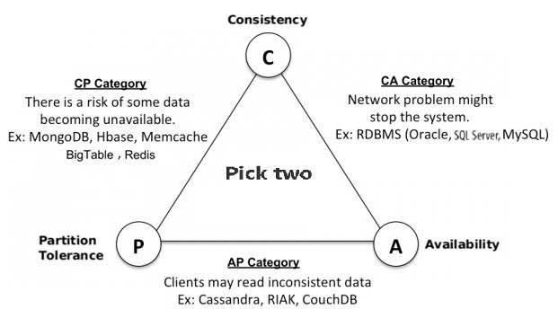

B)
<Person>
<name>Henry Story</name>
<mbox>hj@bbifish.net</mbox>
<knows>
<Person>
<name>Jonathan Story</name>
<mbox>jonathan.story@eg.edu</mbox>
</Person>
<Person>
<name>Tim Bray</name>
<mbox>Tim.Bray@eg.com</mbox>
</Person>
</knows>
</Person>
Q5. A)
Server computing capacity problem – The thin clients waged too many applications.
Single-point Data Storage Problem - When a single data resource is (unexpected) demanded by an overwhelming number of clients, (i.e., a single data item is to be requested by many users).
Traffic Problem - When a destination Web Server is to be visited by too many clients.
Storage and Traffic Problem - When a server needs to maintain far too many incoming data streams (upstream) or outgoing data streams (down streams) for file exchanges.
Network Congestion Problem – When the demands of the (web) services is over the server’s capacity.
Dynamic Change of the Clients Demands – The clients’ demands of services are unpredictable and may change dramatically
B)
In a centralised architecture, all or most data processing and computing processes are managed by the central servers.
In a decentralized architecture, servers are scattered in geographical areas with different centres undertaking different services.
In a distributed (peer-to-peer or P2P) architecture, nodes are working as either clients or servers, or both.
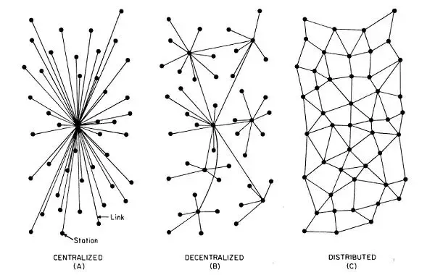

Q6.

A)
Yes, Apache spark uses IMC which enable the map process to happen in main memory while hadoop’s mapreduce is performed using hard disk which is 100x slower compared to spark.

B)
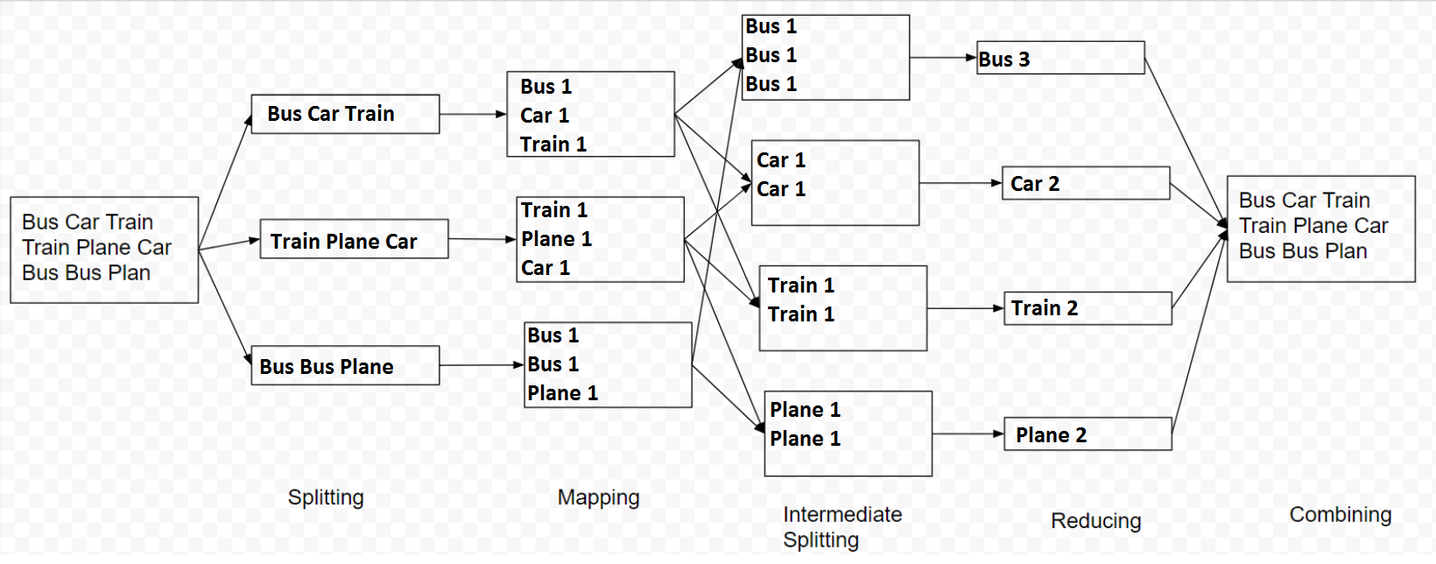

Not sure how this question works, is it supposed to have plane and plan or is it just a typo?
I think it's a typo, otherwise there would be an extra box at the reducing phase

Q7. A) - since in the question you see cqlsh:stock> using Stock.table_name would actually throw an error I am pretty sure.

- Yeah no need to specify stock because its already using keyspace stock

SELECT * FROM Stock.Product_info WHERE Product_name = ‘iphone Xs’;
B)
UPDATE Stock.Product_info SET Price = 2308 WHERE Product_name = ‘iPhone Xs Max’;

C)
DELETE FROM Stock.product_info WHERE Product_name = ‘iPhone X’;
D)
INSERT INTO Stock.Product_info(Id, Product_name, Price, Unit) VALUES(5, ‘iPad Mini’, 700, 1800);
Q8.

A)
Issues digital signatures, certifying the ownership of a public key by a named subject.
B)
Confidentiality (Encryption/cryptography) - Will my transaction remain a secret?
Authentication (Digital certificates) - How can I be sure of who I am transacting to?
Integrity (Digital Signatures) - How can I be sure my transaction is not altered without my permission?
Non-repudiation - How can I be sure that a transaction is not denied by a party?

_|\ _/|_,
,((\\``-\\\\_
,(()) `))\
,(())) ,_ \
((())' | \
))))) >.__ \
(((' / `-. .c|
/ `-`'
ヽ༼ ຈل͜ຈ༼ ·̿̿Ĺ̯̿̿·̿ ̿༽Ɵ͆ل͜Ɵ͆ ༽ﾉ

C)
Allows for search of specific information in encrypted content. The message stays encrypted, but the service provider knows what to do without reading it.
D)
If there are 10 possible sets, there will be 20 keys (10 for Alice and 10 for Bob).
The first set of keys refer to all values Alice can choose and the second set of keys refer to all values Bob can choose from. Only 2 keys will actually be used however. After Alice has selected her value she ‘leaves the room’ leaving her selected key in the room and lets Bob choose his value. Once Bob has selected his value he uses his key to open one of the boxes and then uses alice’s key to open the inner box which contains the result.

E)
Alice has 1 Pubkey + 1 Privkey => Shared secret

Alices public key is first used to generate a searchable encryption of her chosen word
Alices private key is then used to encrypt her chosen search word to produce a trapdoor.

Bob then uses her public key to decrypt the image he found using alice’s trapdoor search term.
Q9.
A)
RDD is a resilient distributed dataset.
- Fundamental data structure in Spark.
- Immutable, distributed collection of objects, read only.
- Divided into logical partitions, may be computed on different nodes.

B)
IMC is architecture where applications assume all data required for processing is in main memory. (Spark uses this)
- Improves responding time 5,000x
- Reduces bottleneck of latency storage hard disks.
- Supports scale up / scale out.

EXTRA Questions

What is the core cloud computing technologies?

- Virtualization
- distributed data storage
- Programming model
- Information security
- Distributed resource management
- Information security
- Energy saving

When to use SQL v NoSQL?

- SQL: complex queries, ACID, joins, enterprise support, schema
- NoSQL: clusters, CAP, no heavy schema, document based, community support

What is Spark?

- Fast and general engine for large scale data processing.
- Faster than hadoop mapreduce.
- Cluster computing framework, does not have own DFS, can use HDFS.
- Ease of use with API for Python,Scala,Java.
- Uses IMC.

What is BigTable?

- Uses DFS for reliability.
- Not RDBMS, sparse M-D map.
- Spreads across commodity servers.

Benefits of GFS?

- Scalability & availability
- Built for hardware failure.
- Appending writes instead of overwrite.
- Networking (cluster/racks)
- High sustained bandwidth.

What are the requirements of cloud computing for security and privacy?
Data confidentiality
Data integrity
Data access controllability
Data sharing
Data utility
Data privacy
What is searchable encryption?

Important Memes:

